PDC Assignment 3

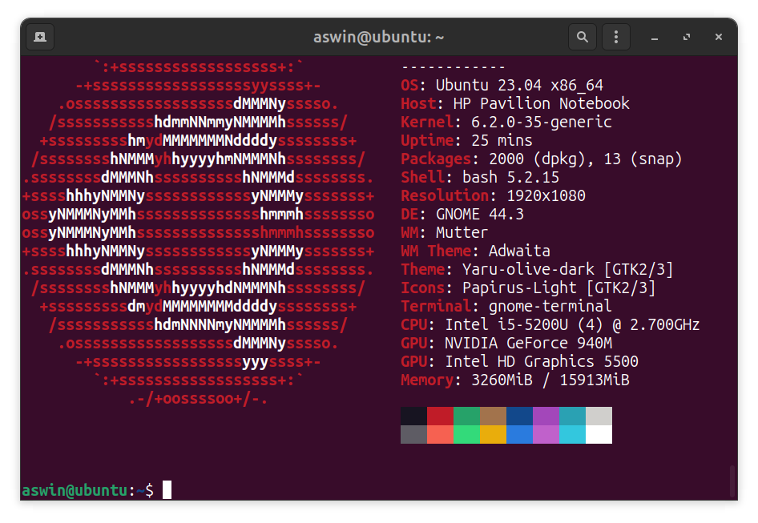

Single Processor with values , 10^4, 10^5, 10^6 anfd 10^7

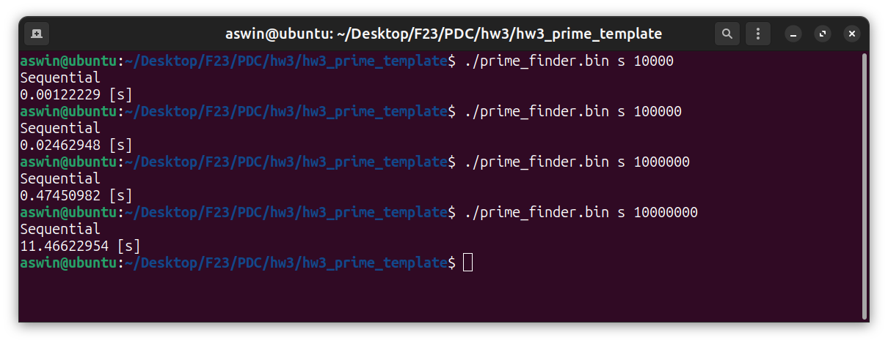

1 Thread with values , 10^4, 10^5, 10^6 anfd 10^7

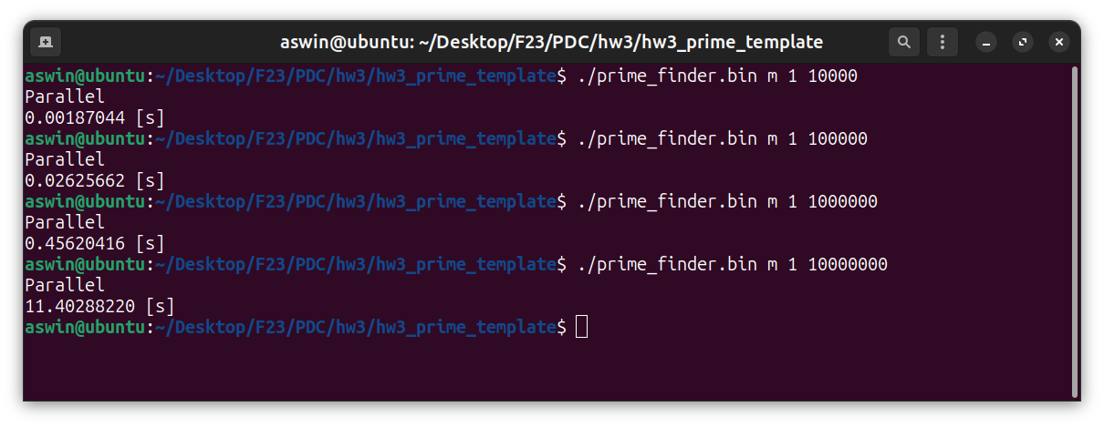

2 Threads with values , 10^4, 10^5, 10^6 anfd 10^7

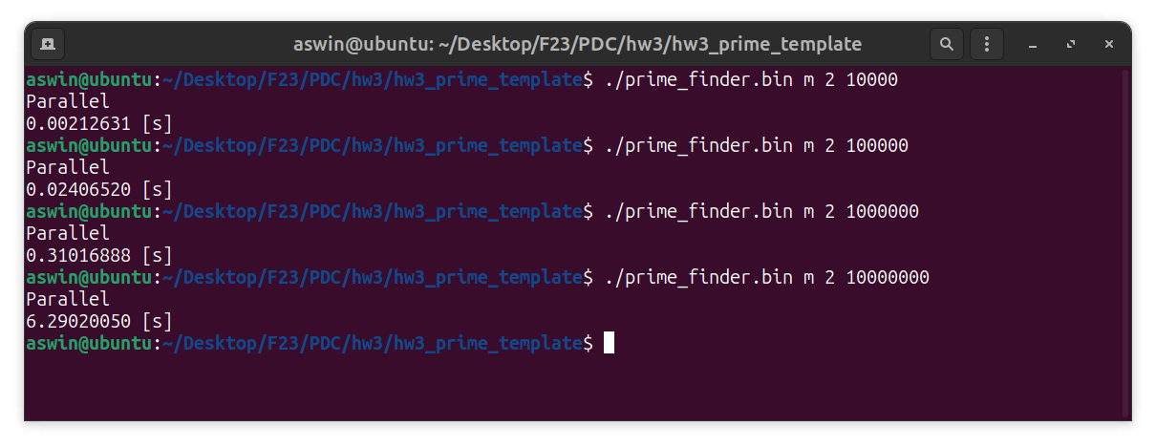
4 Threads with values , 10^4, 10^5, 10^6 anfd 10^7

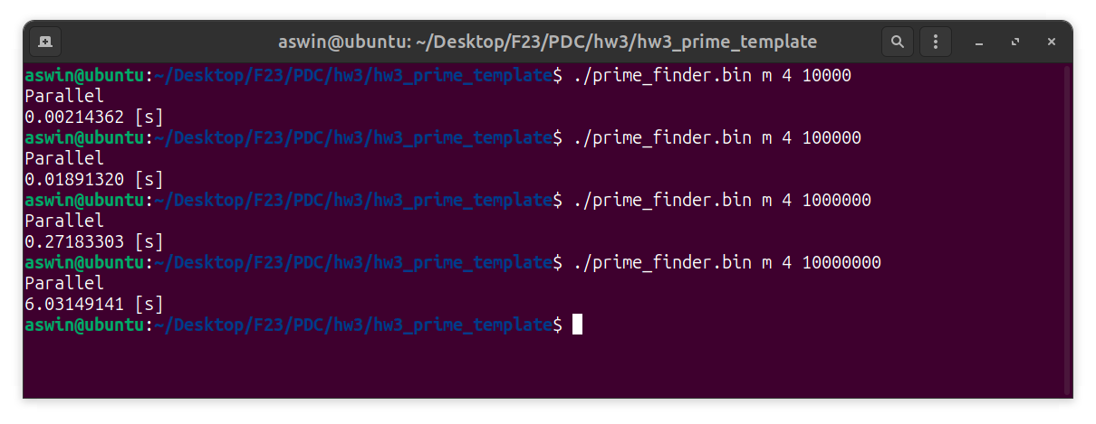

6 Threads with values , 10^4, 10^5, 10^6 anfd 10^7

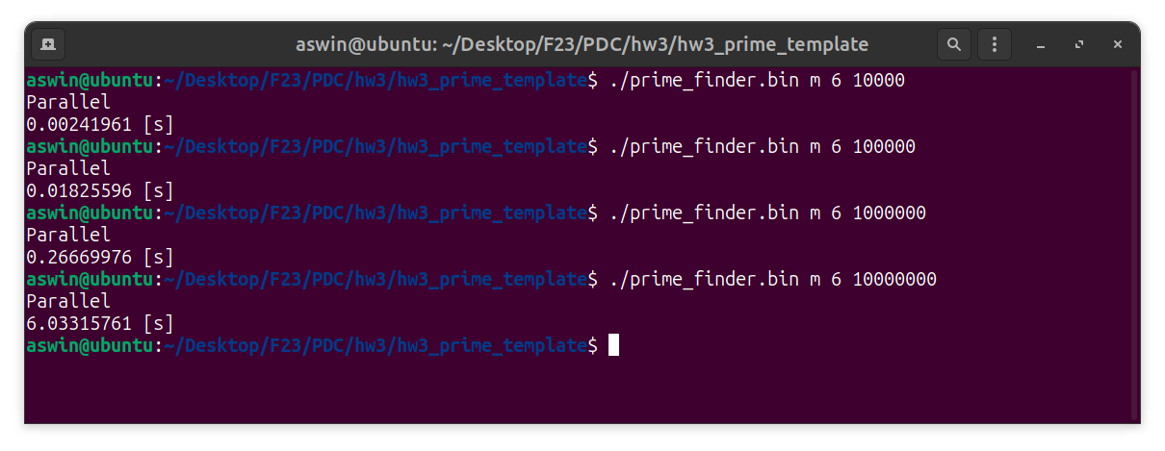

8 Threads with values 10^4, 10^5, 10^6 anfd 10^7

